Adding New Periods vs. New Modifications Cheat Sheet
Updated 3.10.20

New Periods – Used when the start date of the next award action is following the end date of the previous award.
“New period” is appropriate for a new funding increment for a subsequent year of funding.

New Modifications – Used when the modification in question does not extend the dates but modifies an existing period, or when the start date will remain the same but the end date is being extended.
Example:
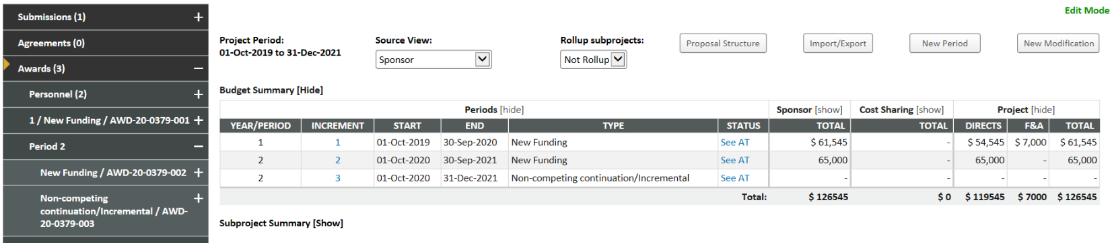
- Award action 001 was the first year and so New Period was the only option when adding the award.
  - Reasoning – Award action 001 can only be added as a New Period. New Modification is not available until the first award action has been added in eTRACS.
  - Year/Period = 1
  - Increment = 1
- Award action 002 was a subsequent year of funding so New Period is chosen when adding this award.
  - Reasoning – The start date of this award action is the day after the end date of the previous action
  - Year/Period = 2
  - Increment = 2
- Award action 003 is a no cost extension to the final year of the award, so it was added as a New Modification by choosing to “Link to Period” 2. (Note: The “Link to Period” feature is only available when you choose New Modification; see below)
  - Reasoning – the start date remained the same from action 002, but the end date is being extended
  - Year/Period = 2
  - Increment = 3
