Modular Budget Development
Updated 10.17.19

How to develop and modular budget:
The option to submit a modular budget to NIH is only available if the proposal is linked to the Grants.gov opportunity number when initiated in eTRACS. See “Starting a New Federal Proposal” training guide or help video for more information.
- On the Set Up Questions tab of the proposal, choose the Modular Budget option under the federal Forms section.
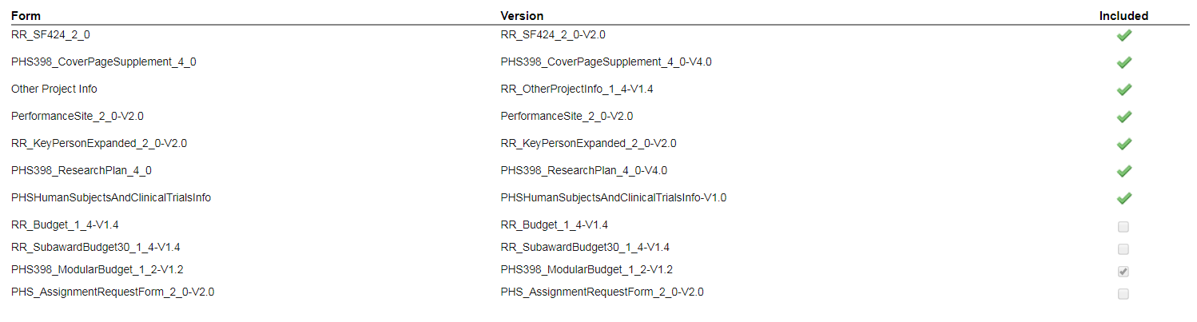
- Develop the remaining tabs of the proposal. See the Creating Proposals section at etracs.ecu.edu/help.
- eTRACS will require that a budget be built in the standard Budget tab, but a “Modular Budget” tab will be available.
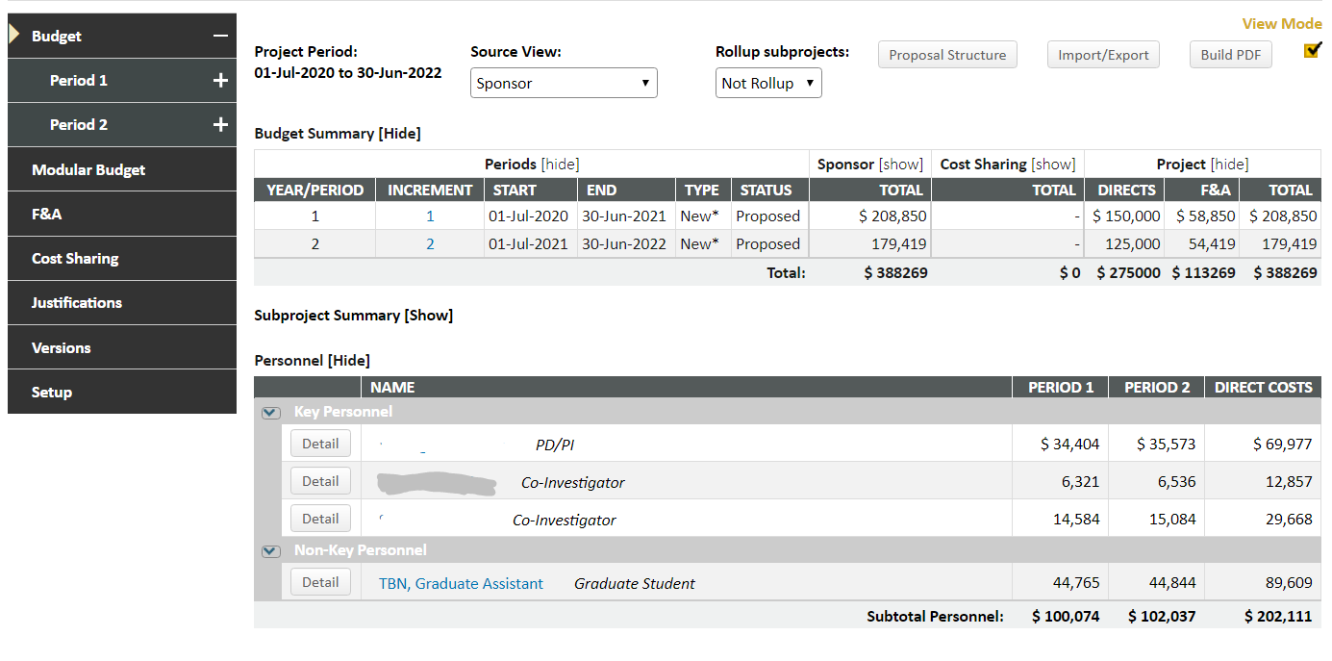
- After building the budget, navigate to the Modular Budget tab. Choose the number of modules per budget period > Save.
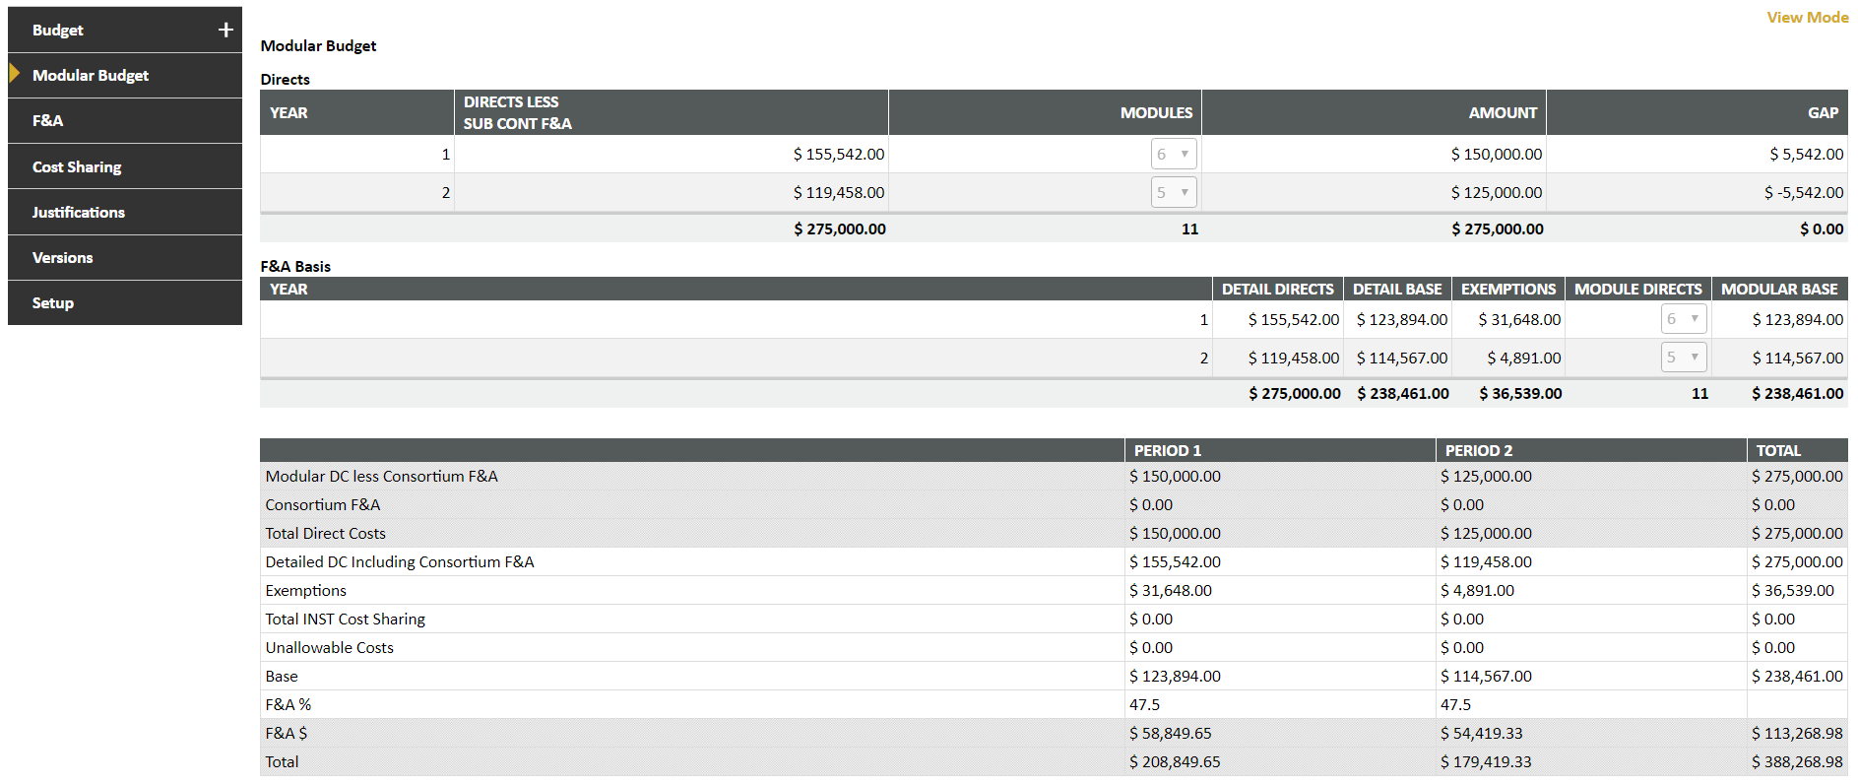
- Navigate to the Justifications tab to see the additional justification documents suggested for modular budgets.
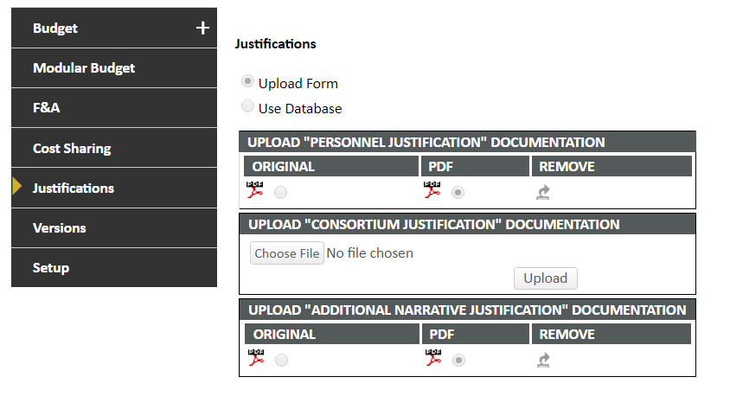
- Finish developing the proposal, navigate to the finalize tab and build the submission package > Submit for final routing.

