Master Record Controls (Supplemental or Incremental Submissions)
Updated 3.10.2020
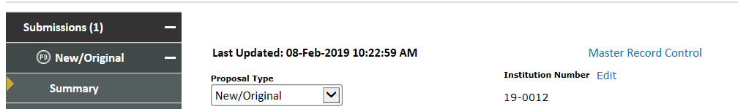
Definitions:
Master Record Control: The feature that allows you to associate a proposal as a child of a parent submission in order to keep award information within the same Proposal Tracking (PT)/Award Tracking (AT) record.
Parent Record: A parent record is an original proposal to the sponsor.
Child Record: A child record is a supplemental or incremental submission to an original proposal.

Who can use Master Record Controls?
Only research administrators that have access to the PT and AT record may use the Master Record Controls. Investigators will initiate supplemental and incremental submissions like a new or original proposal and will change their type to the appropriate designation.

Using Master Record Controls:
In the instance where a submission needs to be made a child of another parent submission, the research administrator should:
- Find and remember the proposal number that will be the parent record.
- Navigate to the PT record of the child proposal.

- You will land on the summary page of the current submission. In the top center, click on “Master Record Control.”
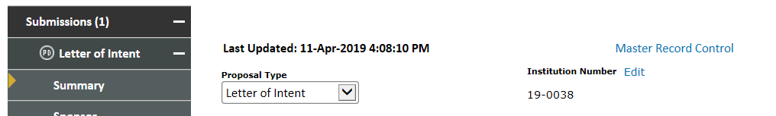
- A pop-up window will appear prompting you to fill in the parent proposal number. Type in the number and hit save.
- An additional window will populate to summarize the migration that will take place. You can hover over the magnifying glass to get more information on each line item. Hit save to close this window.
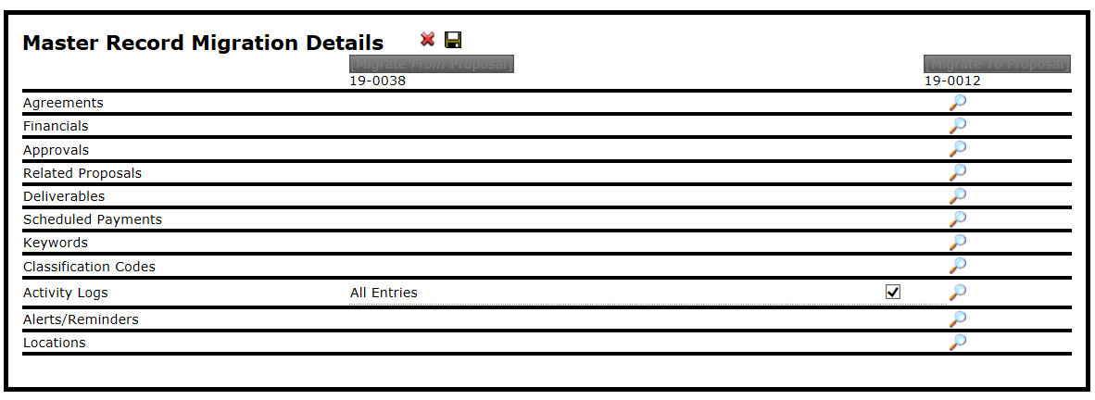
- The child proposal will now show up under the Submissions in the left-hand navigation. Whenever navigating to either submission PT/AT record, they will appear within the same parent record.
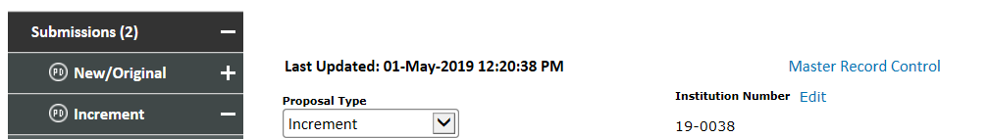

Notes:
- Coversheets will always pull data from the original submission in which the record is numbered. All coversheets should be generated from the project Communications tab (black tab closer to the bottom of the PT record) and not the Submission Communications tab (gray tab under the submission section).
- Approval compliance records must be added to the parent project “Approvals” tab (under the Submissions section) for those records to populate on the coversheet.
- Agreements records can be added specifically to the submission in which they are associated. (Agreement record information does not populate on the coversheet)

