Linkages – Related Proposals
Updated 5.1.19
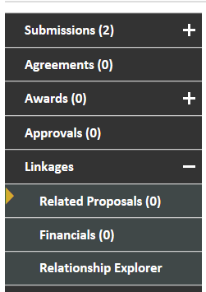
Definitions:
Linkages: The section of the Proposal Tracking (PT) record where a proposal can be tied to another type of non-submission record.
Related Proposals: The section under linkages where a related proposal can be designated.
Non-Submission records: A record that can be linked and related to a proposal record. Such records include, but are not limited to: non-disclosure agreement, master agreement and materials transfer agreement.

What types of records can be linked?
Proposal Tracking records should only be linked to non-submission records as defined above. The record should already be created in eTRACS prior to linking in the proposal record.

Linking Related Proposals:
- Navigate to the PT record of the proposal.
- In the left-hand navigation window click on Linkages > Related Proposals.

- In the top right-hand corner click on “Link to Existing.”
- A window will populate that will allow you to search for the related record or to type in the number directly.
  - To search for a record: Select a parameter option and keep all the proposal statuses checked > Click Go > records will populate at the bottom of the screen > Check the box to the right of the record that
applies > Click Select

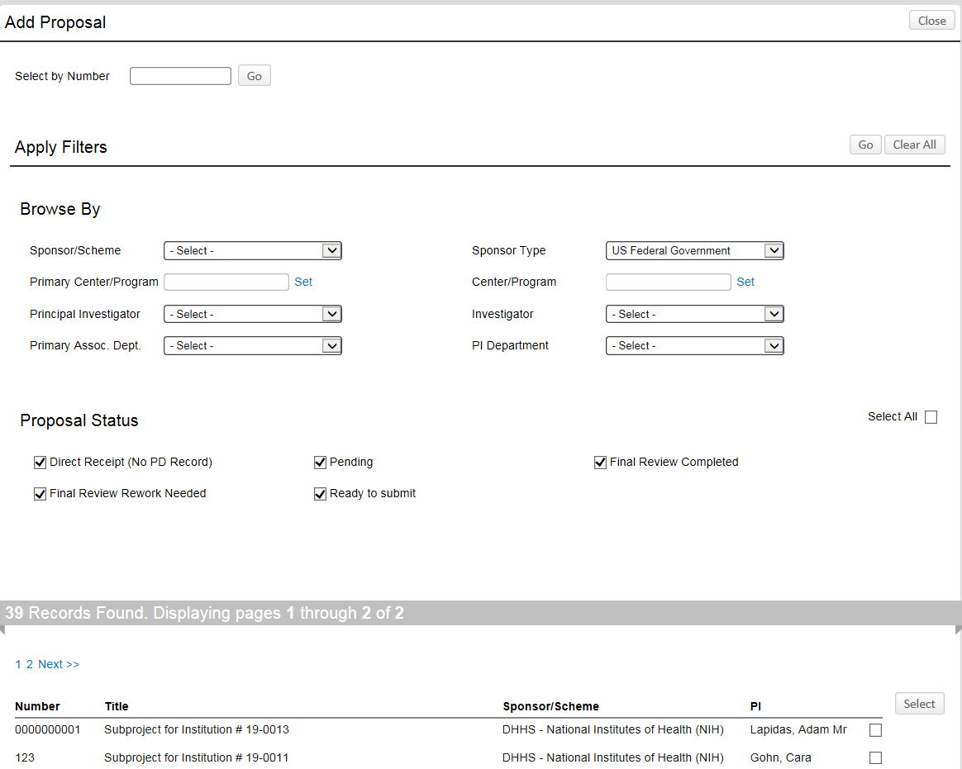

  - If you know the record number: Type in the number > Click Go > Proposal will populate at the bottom of the screen > Check the box to the right of the record > Click Select
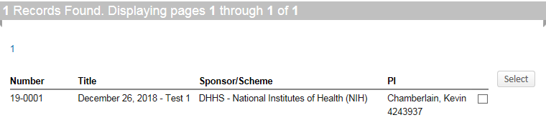
- The pop-up window will close and the related record will now appear in the PT record.
