Email Fetching
Updated 8.12.19

What is Email Fetching?
Email fetching is the capability of eTRACS to grab emails from Outlook where the eTRACS record number is cited and attaches it to the Communications tab in eTRACS.

How to utilize email fetching:
When sending an email to an individual, cc etracs@ecu.edu. Reference the proposal record number in the subject line or body of the email. The email can take up to a few hours to be visible in eTRACS. All responses that cc etracs@ecu.edu will also be captured.
NOTE: Projects will have the same numbering convention as the proposal with an “AWD” prefix. Remove that prefix to attach to the PT record.
Proposal = 20-0005
Project = AWD-20-0005
Award = AWD-20-0005-001
Number to Reference in Email = 20-0005
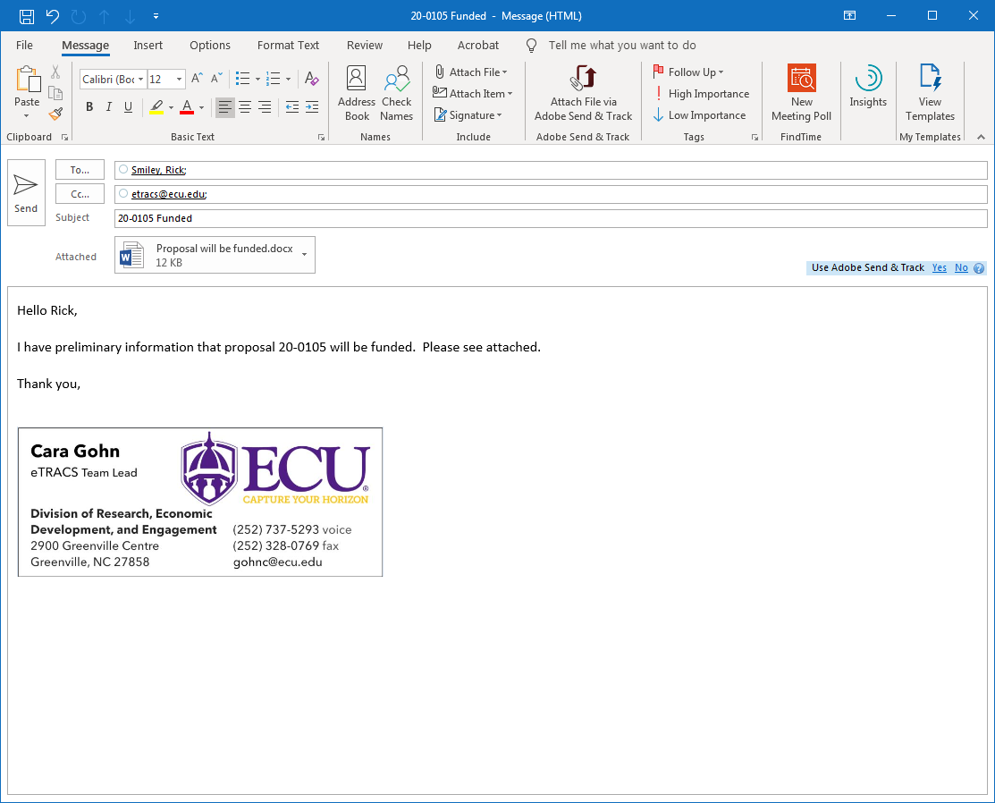

How to view emails fetched within the eTRACS record:
In the PT record, the emails fetched can be found in the Communications tab. View the email by clicking on the “Detail” icon.
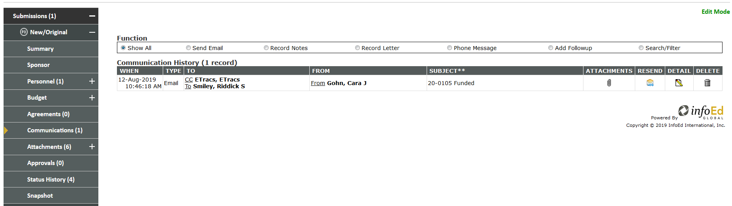

Any attachments in the email can be found in the Attachments tab of the PT record.
