Deobligation Award Actions
Updated 4.14.2020

Included in this document:

Pre-Requisites | Page 1
Deobligation Award Types | Page 1
How to Change the Admin Department | Page 2
How to add a “Deobligation – Carryforward” Award Actions | Page 3
How to add all other Deobligation Award Actions | Page 3

Pre-requisites:
Familiarity with adding awards in eTRACS. See “Adding a New Award” training document and the “Adding Awards Checklist.”

Deobligation Award Types:
A deobligation will be added as an award action and be categorized with its own “type” within the Award Increment of the AT record.
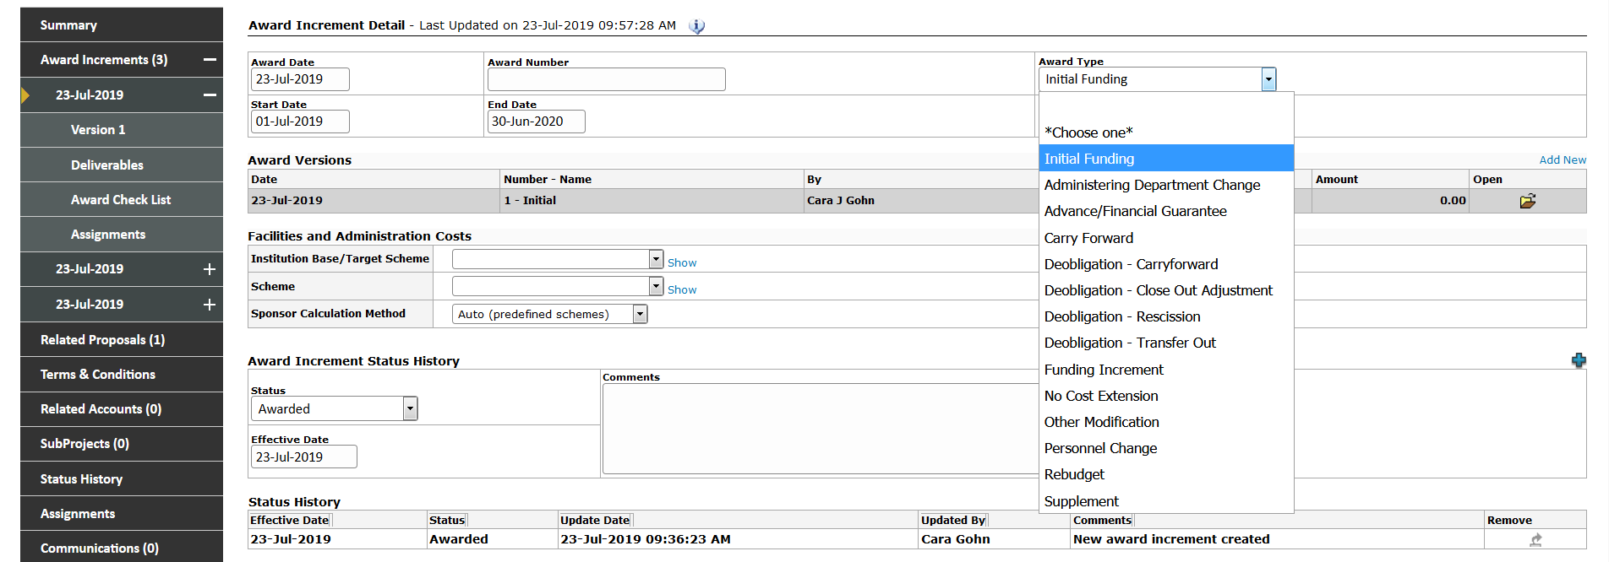
Administering Department Change: When an admin department changes, the unspent funding that will transfer to the new department will be deobligated with one award action and re-awarded in an additional action to the new admin department. All of these actions take place within the same project PT and AT records.
Deobligation – Carryforward: In the scenario where a sponsor deobligates an unspent amount from a prior award period and awards that amount in addition to the next period of funding, the unspent amount must be deobligated so as not to double count the carryforward dollars.
Deobligation – Close Out Adjustment: If a sponsor sends a deobligation Notice of Award due to unspent money at closeout, use this award type.
Deobligation – Rescission: Rescissions of funding from the sponsor, that do not include closeout actions, will use this award type. One such action is a deobligation Notice of Award from the sponsor for unallowed carryforward.
Deobligation – Transfer Out: This scenario occurs when a PI leaves the institution and takes the remaining award dollars to a new institution. Only the award amount unspent and transferred should be deobligated.

How to Deobligate from one department and Obligate to another:
See the “Adding a Mid-Project Budget Modification” section of the “Adding a New Award” training document and follow these steps:
Deobligate from the terminating department:
- Add a new Budget modification in the PT requested budget (under the Submissions tab)
  - Modify the end date of the period to reflect the date in which the old department is terminating the award
  - edit the new budget increment to reflect the negative amount unspent by the old admin department
- Add an award in the awards tab and copy in the new budget increment you created
  - Submission Type = Non-Competing continuation/Increment
  - Award Type = Administering Department Change
- Follow the Awarding Checklist and process the packet to post-award
Obligate to the new department:
- Change the admin department on the PT summary screen
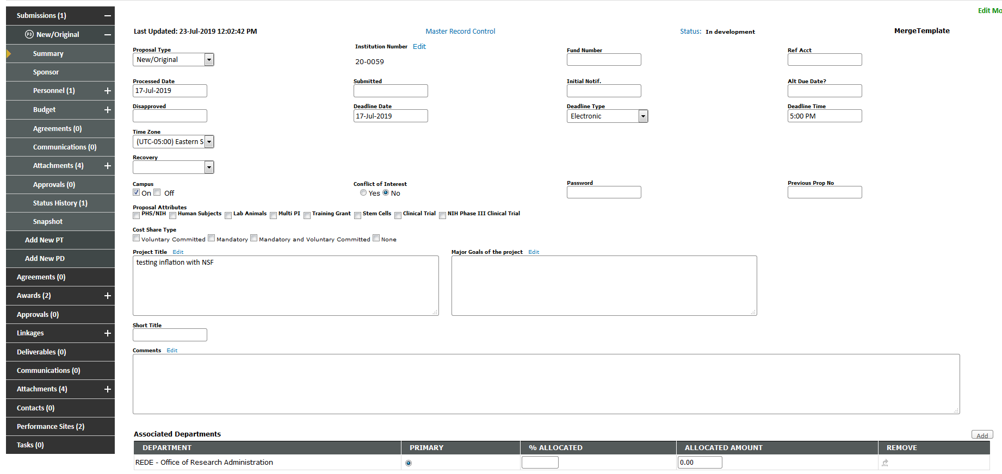
- Click Add
- Search for the new admin department name > Click Select
- Update the “Primary” status using the radio button next to the new department > Save
- Add another new Budget modification to the PT requested budget (under the Submissions tab)
  - Start date of the new increment should reflect the effective date of the new admin department (and should match the end date of the relinquishing department’s award
- Add an award in the awards tab and copy in the new budget increment you created
  - Submission Type = Non-Competing continuation/Increment
  - Award Type = Administering Department Change

NOTE: Admin department will be changed within the increment to reflect the new selection
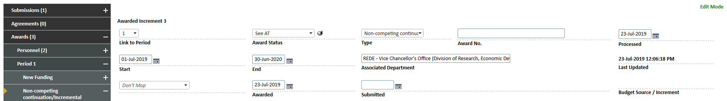
- Follow the Awarding Checklist and process the packet to post-award

How to add a “Deobligation – Carryforward” Award Action:
See the “Adding a Mid-Project Budget Modification” section of the “Adding a New Award” training document and follow these steps:
- Add a new Budget modification in PT requested (under the Submissions tab) and edit the budget to reflect the negative amount deobligated by the sponsor
- Add a new award and copy in the new budget increment
  - Submission Type = Non-Competing continuation/Increment
  - Award Type = Deobligation – Carryforward
- Process the award action following the “Adding a New Award” training document
- When the NOA is received for the next funding period with the carryforward amount included, award the period following the “Adding a Subsequent Year of Funding” section of the “Adding a New Award” training document.
NOTE: If carryforward is awarded as its own award action, then use Award Type = Carryforward

How to add all other Deobligation Award Actions:
See the “Adding a Mid-Project Budget Modification” section of the “Adding a New Award” training document and follow these steps:
- Add a new Budget modification in PT requested (under the Submissions tab) and edit the budget increment to reflect the negative amount deobligated by the sponsor or transferred out
- Add a new award and copy in the new budget increment
- Submission Type = Non-Competing continuation/Incremental
- Award Type = Deobligation – Close Out Adjustment / Deobligation – Rescission / Deobligation – Transfer Out
- Process the award action following the “Adding a New Award” training document

