Creating a Stand-Alone PT Agreement Record
Updated 6.10.19
Definitions:
PT Agreement Record: An agreement that is separate from a proposal record. A PT Agreement record can be linked to an existing proposal record, if related.
Proposal Type: The field in the PT summary screen that is used to define the type of agreement being tracked with this record. PT Agreement types are listed below:

Confidential Disclosure Agreement
Educational Partnership Agreement
Equipment Use Agreement
Facility Use Agreement
Fiscal Agent Service
In-Kind Grant Agreement
License Agreement
Master Clinical Trial Agreement
Materials Transfer Agreement
Memorandum of Agreement
Memorandum of Understanding
Research Collaboration/Cooperative R&D Agreement
Visiting Scientist Agreement

How to create a new PT Record:
- Navigate to the Proposal Development module and click on “Management Record”
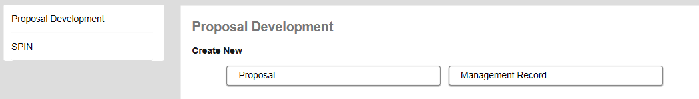
- Choose “New Proposal” > Click Continue
- Fill in the sponsor name > Click Continue
- A PT record will populate. Navigate to the Summary Screen of the PT record and change the proposal type to the type of agreement in which this record will represent.
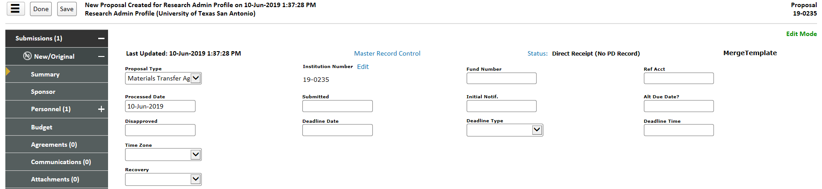
- Fill out all other appropriate data fields and tabs. Track the agreement in the agreements tab of the record. NOTE: See Agreement Tracking training document
- If the agreement can later be linked to a proposal record, utilize the Linkages tab.
NOTE: See Linkages and Related Proposals training document

