

**Manually Closing out the eTRACS Record after Posted to Banner**

Updated 9.26.19

Included in this Document:

Definitions Page 1

How to Close Out an Award Increment record Page 2

Definitions:

**Closing out:** Closing out a record is the action of assigning the fund number and changing the award increment status.

**Award Increment**: The separate award actions that occur within a project to award funding or change project details.

**Award Increment Status**: The statuses of the award once processed for post-award set-up. The two statuses are “Ready to Post to Banner” and “Posted to Banner.”

**Publish**: The action taken to officially assign a Banner fund number to an eTRACS award number.

How to Close out an Award Increment Record:

1. Search for the record in the search bar, hover over the award number > Click Award Tracking

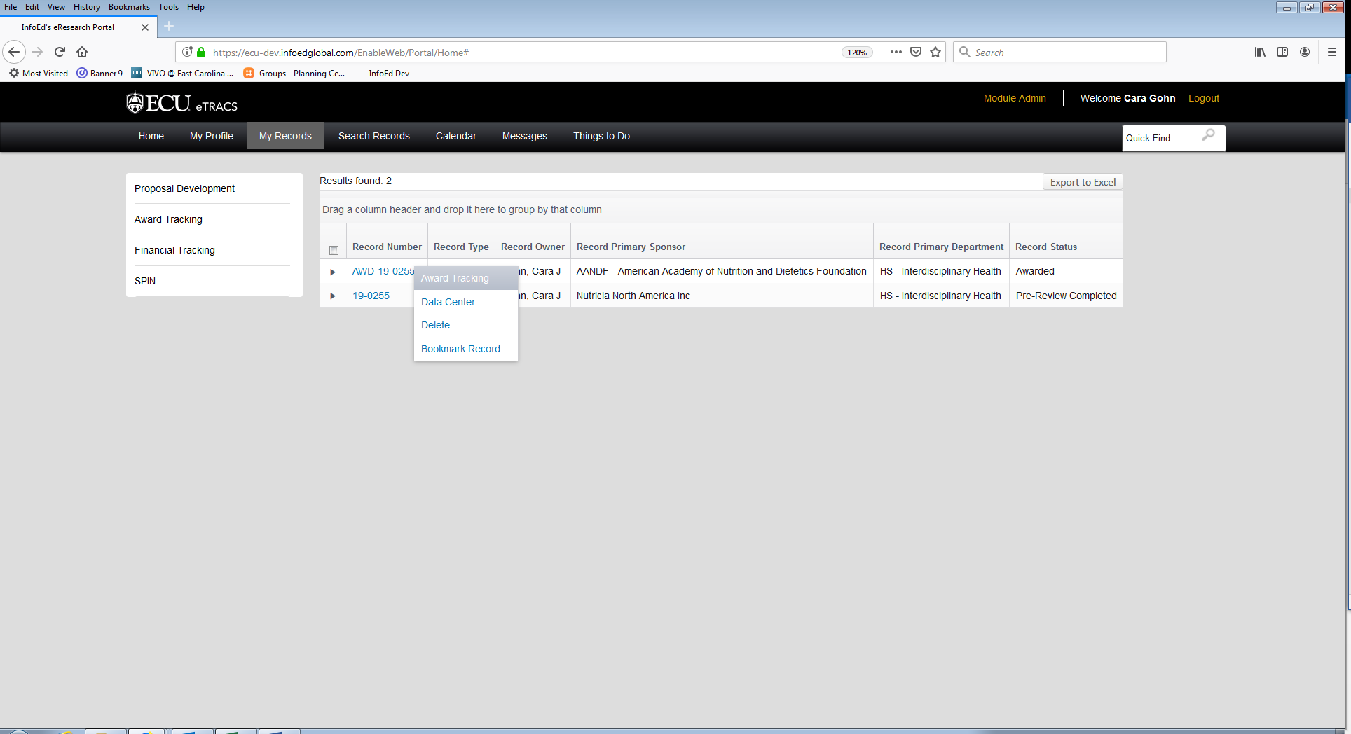

1. On the summary screen, find the award action you need to close under the award Increments section

> Click the Edit icon

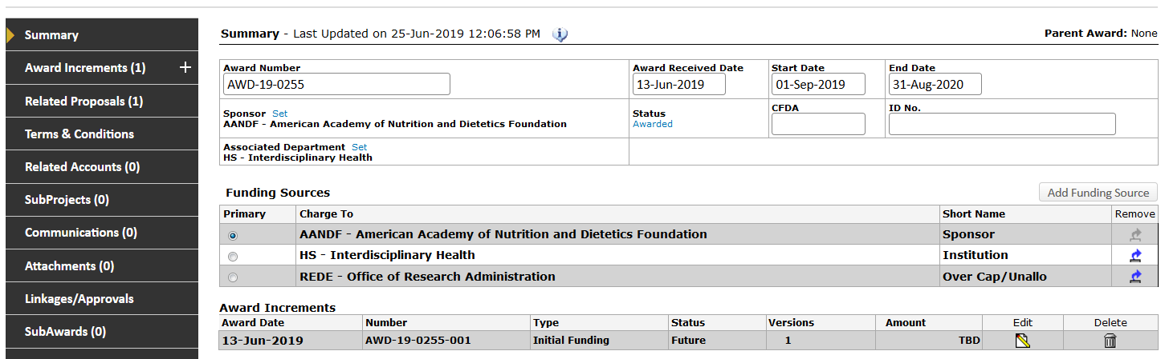

1. Change the Award Increment Status to “Posted to Banner” since banner set-up has already occurred

> Click the Blue + Sign to change the status

1. Check the box under the “Active” Column of the Award Versions > Save

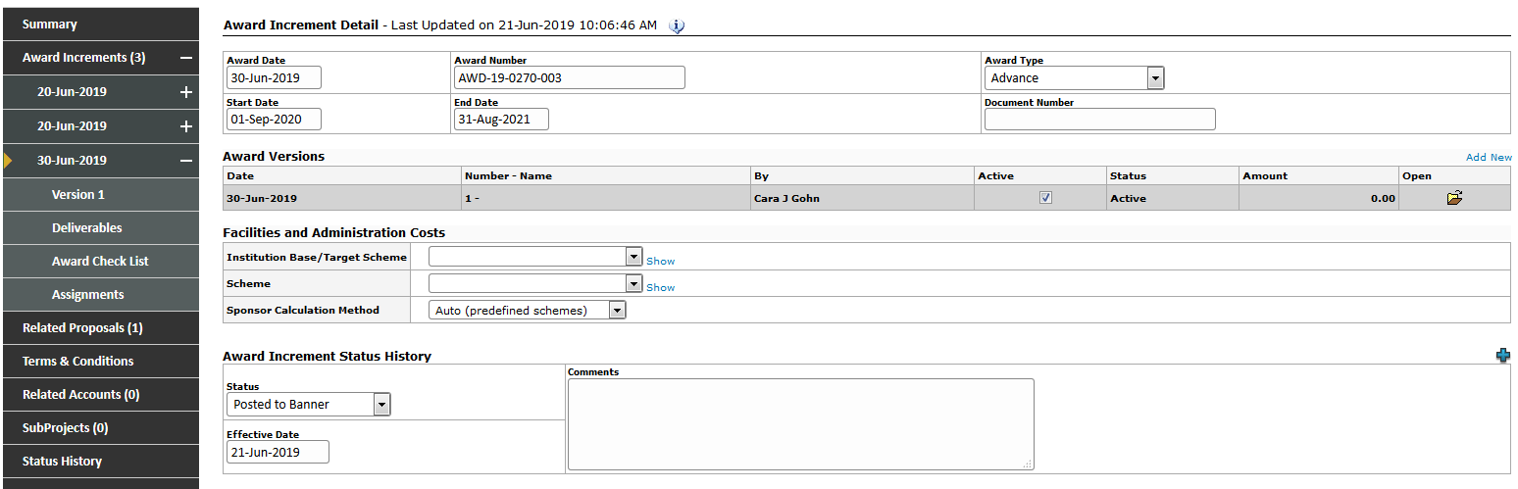

1. Navigate to the Related Accounts tab
2. If the appropriate account is already listed, then proceed to step 20

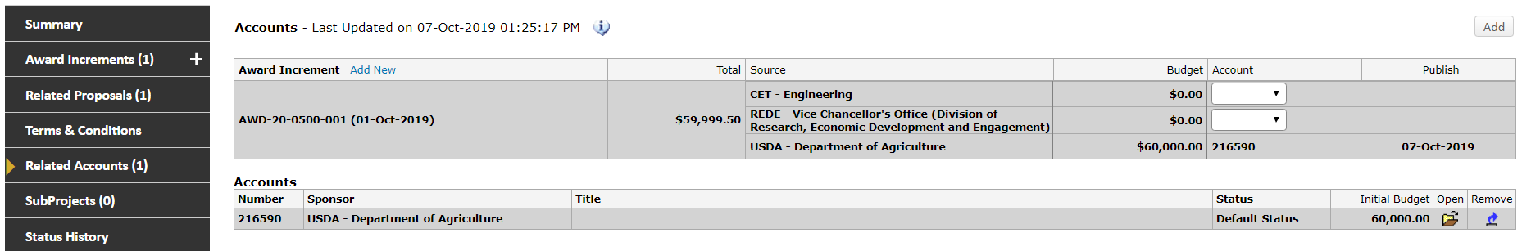

1. Click Add

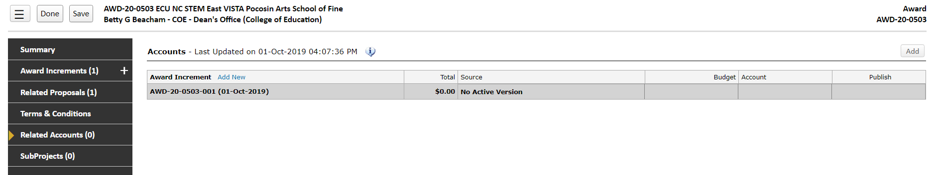

1. Click > Link to Existing Account > Continue



1. Type in the grant number in the “Account Number” field > Click Locate

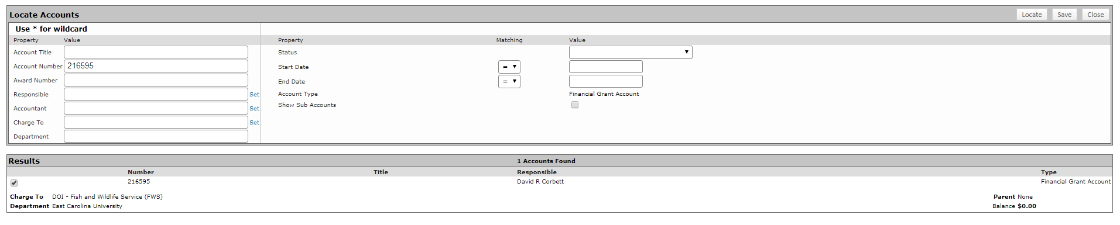

1. If the grant number populates at the bottom of the screen:
   1. Click on the check box next to the grant number
   2. Click Save
   3. Proceed to 18
2. If the grant number does not populate at the bottom of the screen, proceed to step 11.
3. Click Close to exit the “Locate Accounts” Screen
4. On the Related Accounts tab click Add, again
5. Click Create New > Continue



1. Enter the Grant Number in to the Fund box
2. Confirm the dates of the account
3. Enter the PT number



1. Click Create
2. On the next screen > Enter the PT record number > Save > Done

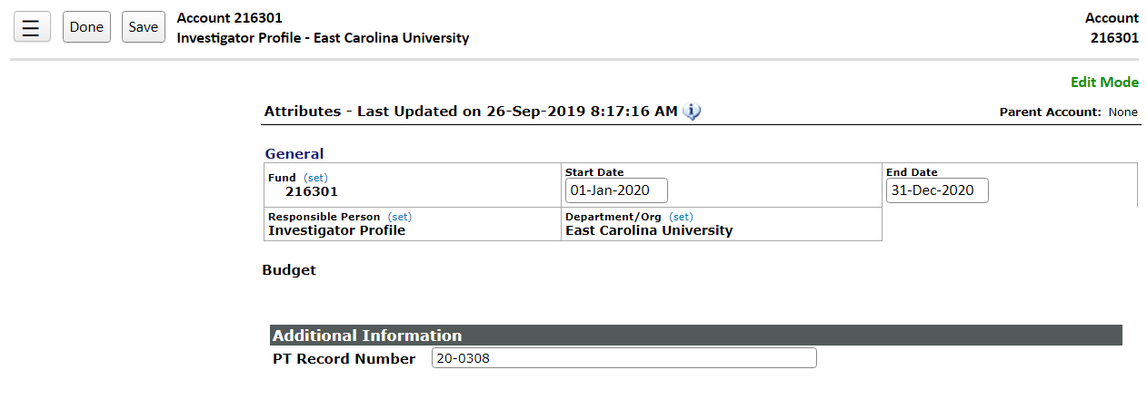

1. Make sure you are still on the Related Accounts tab
2. Next to the Sponsor budget, pick the grant number from the drop down menu and check the publish box > save

