Agreement Tracking
Updated 6.20.19
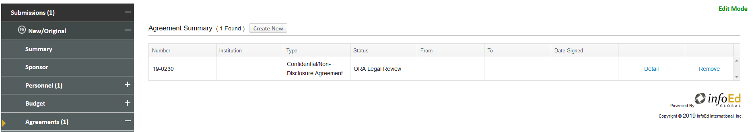
Included in this document:

Definitions
How to Add a Stand Alone Agreement Record
How to Track an Agreement in the Agreements Tab
Changing the Status in the PT Record
Status Definitions
Steps to update the status of the agreement after assigned to you
Page 1
Page 2
Page 3
Page 4
Page 4
Page 6
Attaching Draft Agreements in the PT record Page 7

Definitions:
Agreement: Any Project or Stand Alone agreement, incoming or outgoing, with ECU that may need status tracking in eTRACS.
Stand Alone Agreement: Any agreement that is not yet associated with a project. Such agreements are added as stand-alone Proposal Tracking (PT) records and can be linked to specific projects, as needed.
Project Agreement: Any agreement that is associated with a proposal or record that already exists in eTRACS.
Proposal Tracking (PT) Record: A proposal record that can be developed after-the-fact or as a stand alone agreement that does not require full proposal development and/or routing for approvals.
Agreement Type: The name of the specific agreement that will exist as a stand alone record or as an agreement associated with a project.
Agreement Status: The statuses used to track the location of an incoming or outgoing agreement on the Agreements tab of the PT record.
Agreement Tab: A tab in the PT module that can track statuses of an agreement.
PT Status: The status of the proposal record that may need to be changed if a Notice of Award is received and will be tracked in the Agreement Tab of the existing proposal record.
How to Add a Stand Alone Agreement Record:
- Navigate to the Proposal Development module > Click on Management Record
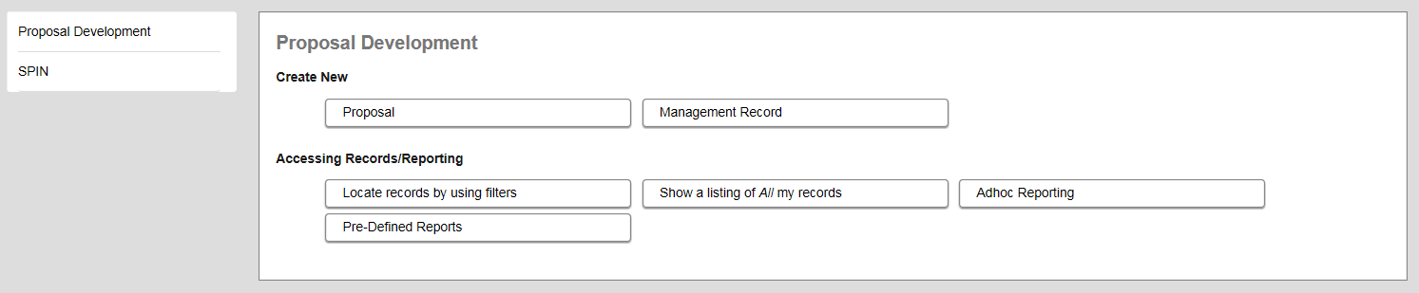

- Create a New Proposal > Continue
- Type in the sponsor name > Continue
- eTRACS will navigate to the PT record
- Click on the New/Original and the summary screen will appear
- Choose the appropriate agreement type by changing the Proposal Type
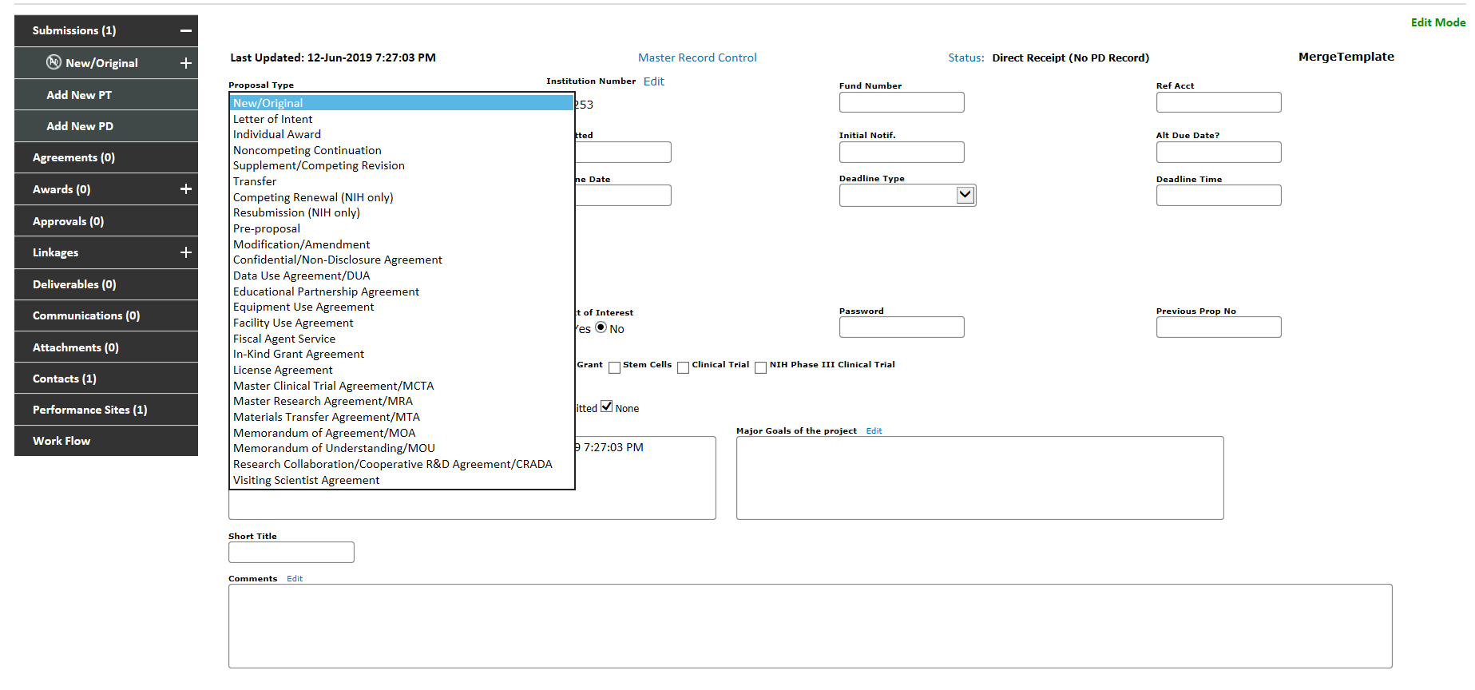
- Complete any other generic agreement information in the summary tab
- Track the agreement by following the instructions in the next section
- Link the stand alone record to an associated project by using the Linkages tab – See Linkages and Related Proposals training document

How to Track an Agreement in the Agreements Tab:
Whether an agreement starts as a stand alone record or will be attached within an existing proposal record, the status can be tracked within the agreements tab.
- Navigate to the Agreements tab of the PT record > Click Create New
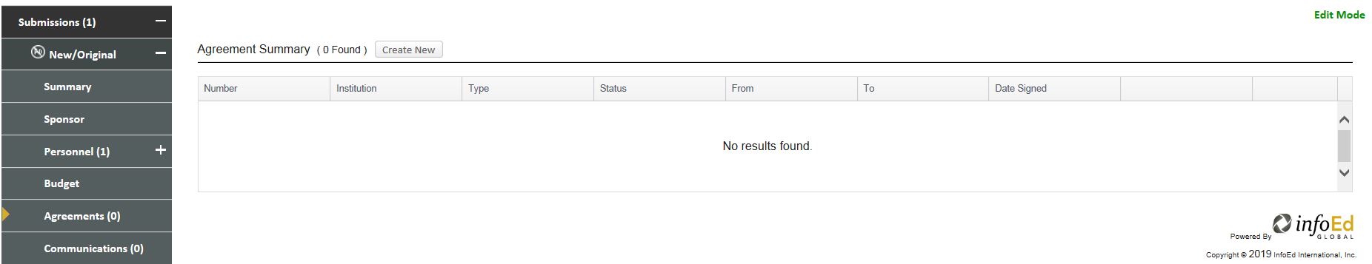
- Choose the Agreement Type and complete all other necessary information
- Update the status to ORA Received or CTO Received and add comments, as needed > Click Add
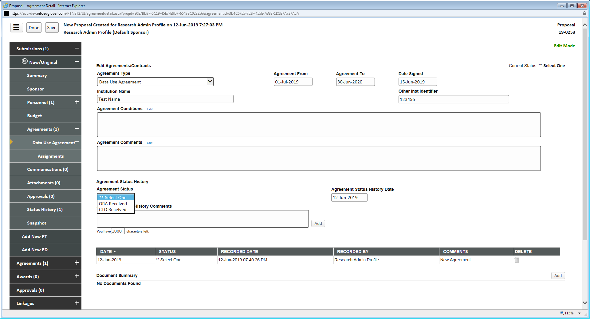
- More statuses will appear and start the status history record
- The latest status will populate at the top of the list of historical statuses in the Agreement Status History section
- Continue to change and track the status until the agreement is finalized or withdrawn
Changing the Status in the PT record for Agreements:
In the instance where a Notice of Award (NOA) is received and will be tracked within the agreements tab of an existing proposal record, the status of the PT record can be changed to reflect that the NOA was received.
- Navigate to the Status History tab under the submission
- Change the Status to NOA Received/Negotiation
  - Add comments, if needed
  - Click Add
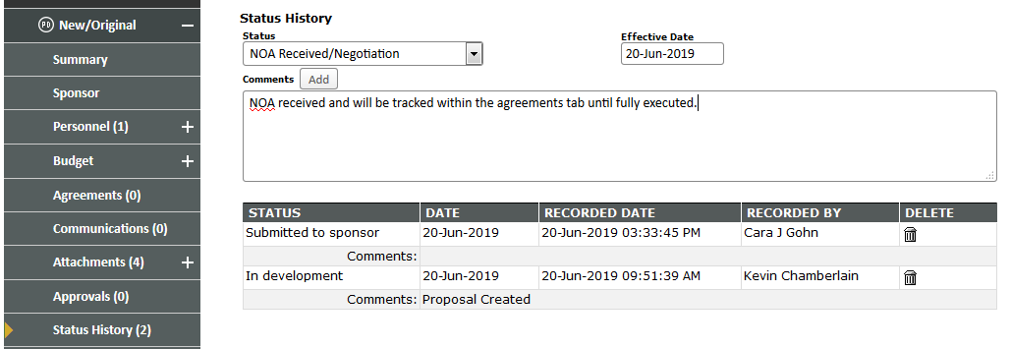

Status Definitions:
ORA Received: An agreement that will be tracked in Central Office
CTO Received: An agreement that will be tracked in the Clinical Trial Office
*ORA/CTO Review: Indicates a review is being done by the individual(s) accepting the award in Central Office/CTO
*ORA Legal Review: Indicates a review is being done by the Central Office contracts/legal specialist
*ORA/CTO Director Review: Indicates a review is being done by the Central Office/CTO Director
*REDE AVCR Review: Indicates a review is being done by the Associate Vice Chancellor for Research
Compliance Review: Indicates a review is being done on the various compliance matters related to the agreement
*PI Review: The status that indicates Central Office/CTO is waiting on the PI for information, acceptance or confirmation
Department Review: The status that indicates Central Office/CTO is waiting on the administering/PI home department for acceptance or confirmation
*Post-Award Review: The status that indicates Central Office is waiting on a post-award manager/administrator for information, acceptance or confirmation
*Pre-Award Review: The status that indicates Central Office is waiting on a pre-award officer for information, acceptance or confirmation
With Sponsor: Indicates that the agreement is awaiting sponsor approval
Finalized: Indicates that the agreement was agreed upon and finalized between both ECU and the other party
Hold: A status used when no further review is required but the agreement has not been fully executed or finalized
Withdrawn: A status used to indicate that an agreement between ECU and the other party was never reached

*Indicates that a group of individuals is assigned to this status and will be notified via the message board on the dashboard/home page of their eTRACS profile.

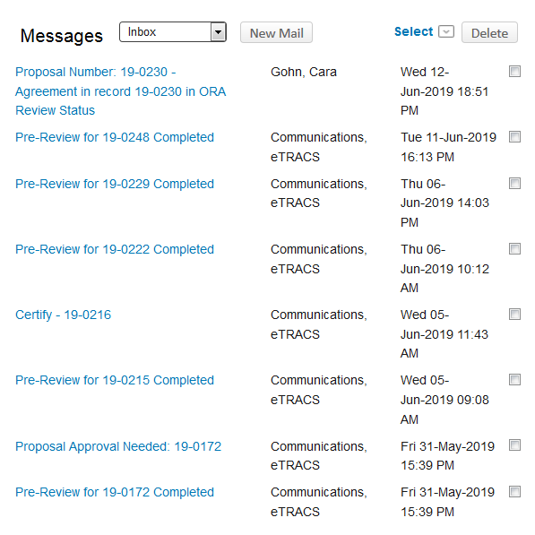

Steps to update the status of the agreement after assigned to you:
- Click on the message title
- The message will open up in a new window > Click Log In
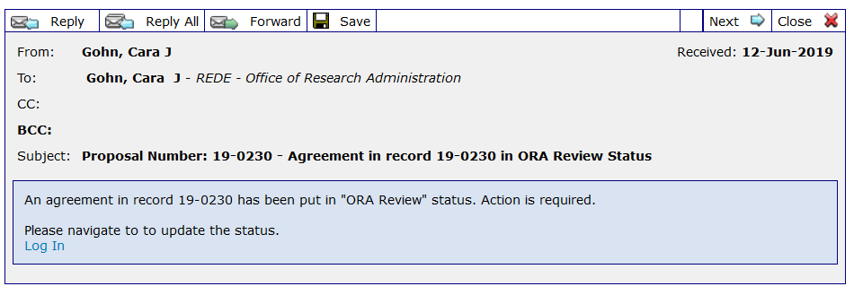
- A new window will pop up with the PT record that will land on the specific agreement
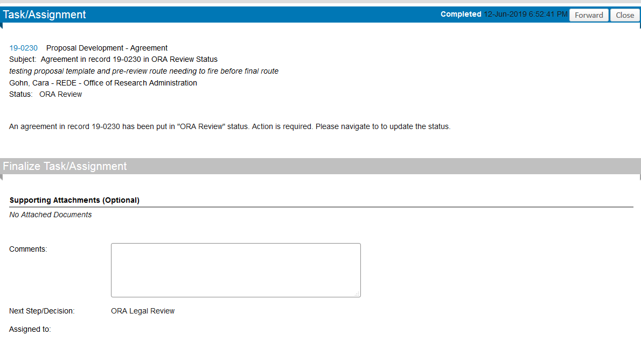
- Update the agreement status by clicking on the drop down menu > add comments > Click Add
NOTE: The status can always be updated by navigating directly to the Agreements tab within the PT record.

Attaching Draft Agreements in the PT record:
Draft Agreements should be attached in the Attachments tab of the PT record. (NOTE: Final versions will be attached in the AT record)
- Navigate to the Attachments tab > Click Add Document
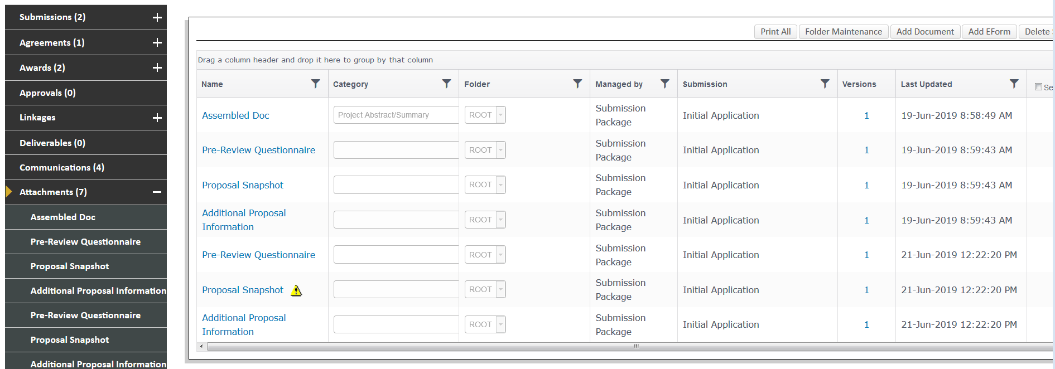
- Browse for the document > Choose a Category > Upload > Change the Name
See “Document Naming Conventions” training document
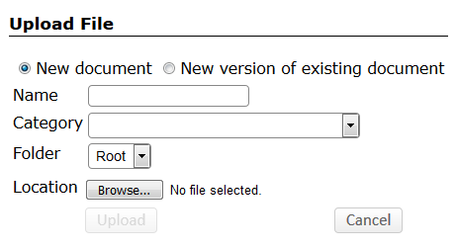
- New versions of existing documents can be uploaded by clicking on “version of an existing document” and choosing the document to update from the drop-down menu
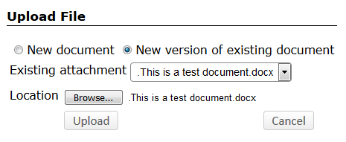
- Previous versions can always be accessed on the Attachments tab under the “versions” column by clicking on the blue hyperlinked number
